Kao Yang
CSD-325 - Module 3 Assignment: Brownfield + Flowchart(s)
Original chohan.py Flowchart - Part 1: Setup, Bet Validation, and Player Choice
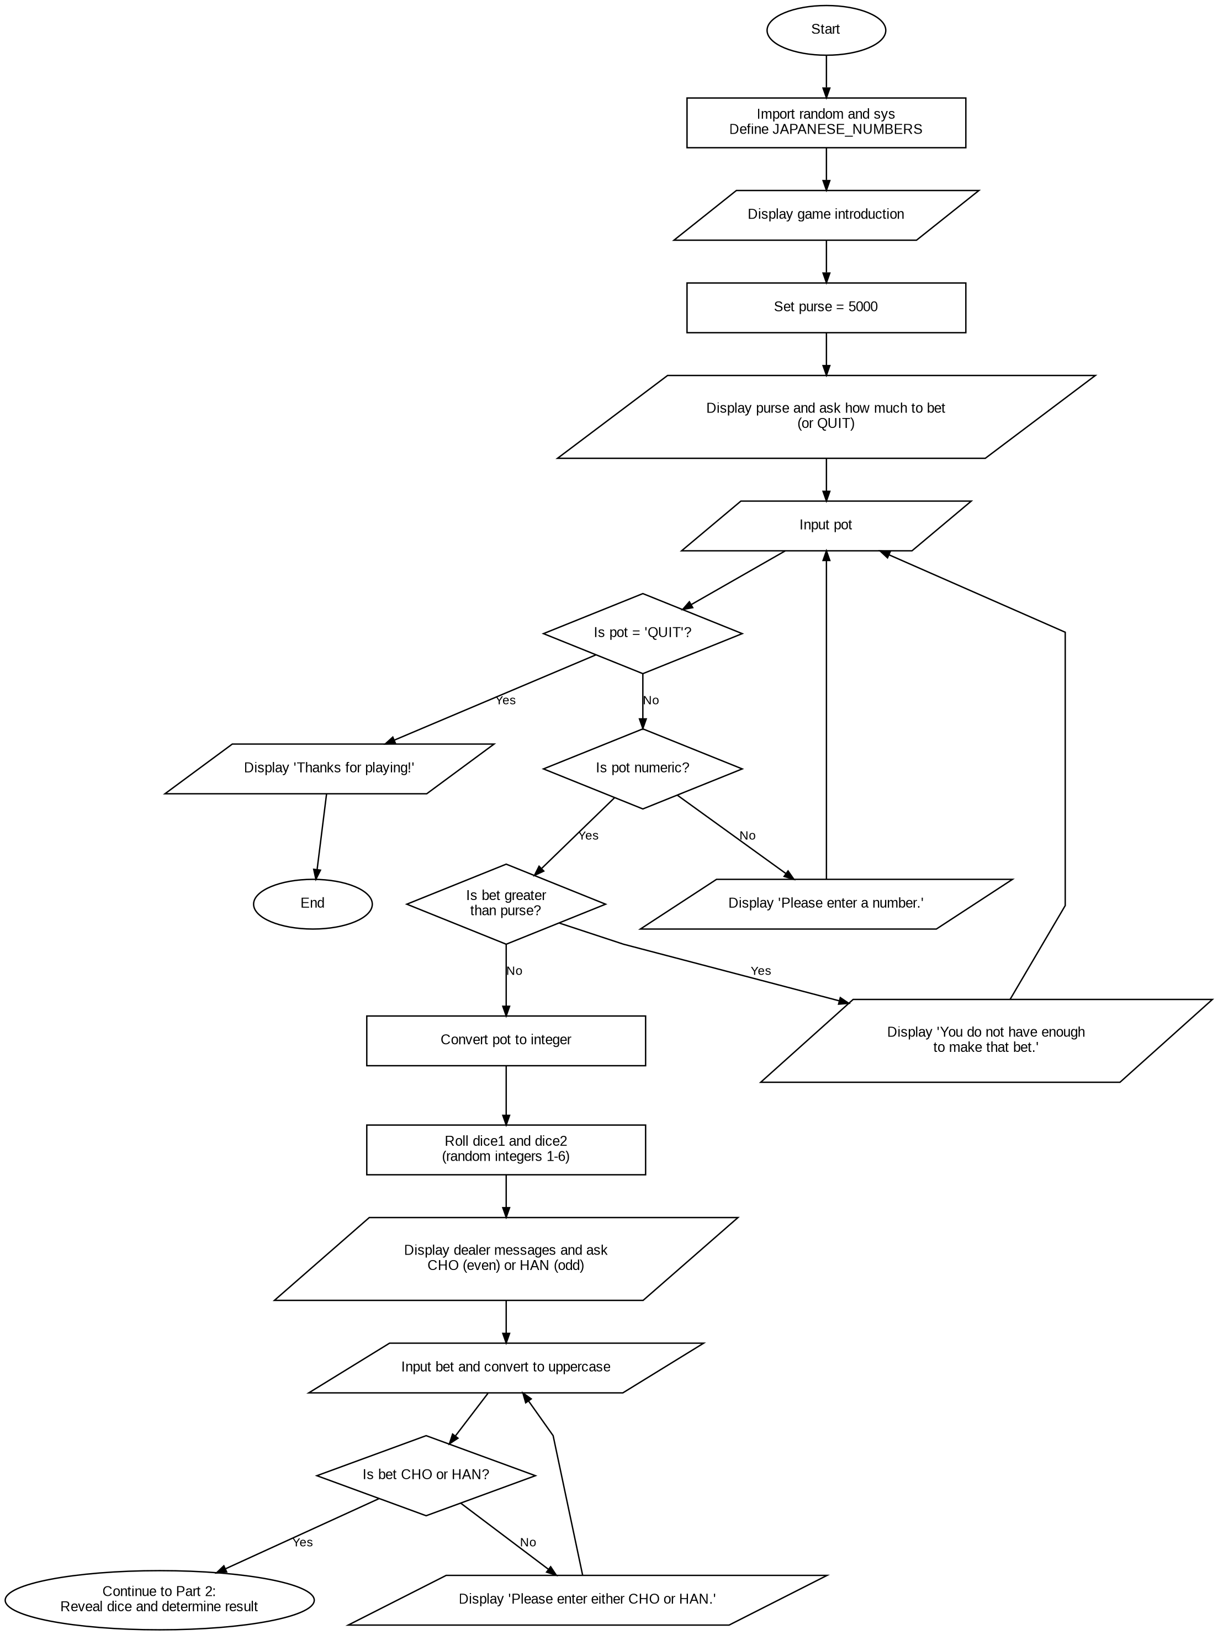

Kao Yang
CSD-325 - Module 3 Assignment: Brownfield + Flowchart(s)
Original chohan.py Flowchart - Part 2: Dice Result, Win/Loss, and Game Loop
